**ONLINE AGRICULTURE PRODUCTS FOR FARMERS**

**ABSTRACT:**

The main objective of this project is to build a website which will help farmers to know about the seed varieties and buy them. This is an ecommerce application for farmers. This project gives a detailed information about the organic varieties of seeds that are cultivated by the farmers. It also gives a wide knowledge about seeds, current seed price and fertilizers. Finally, the user can leave their feedbacks, so that improvements can be done.

**FUNCTIONAL REQUIREMENTS:**

* User can login/signup to the web page which is fetched/stored in the database.
* The home page is displayed.
* Explore the seed varieties and purchase them.
* The API is used to get the live updates about the location.
* User can view the price of many seeds and able to get information about the government schemes.
* User can also get information about the modern technology through youtube videos so that farmers can know all the details that can be used in their agriculture.

**USE CASE DIAGRAM:**





**Navigation Diagram:**

Login

Register

Index

Purchase & Payment

Homepage

**Database Design:**

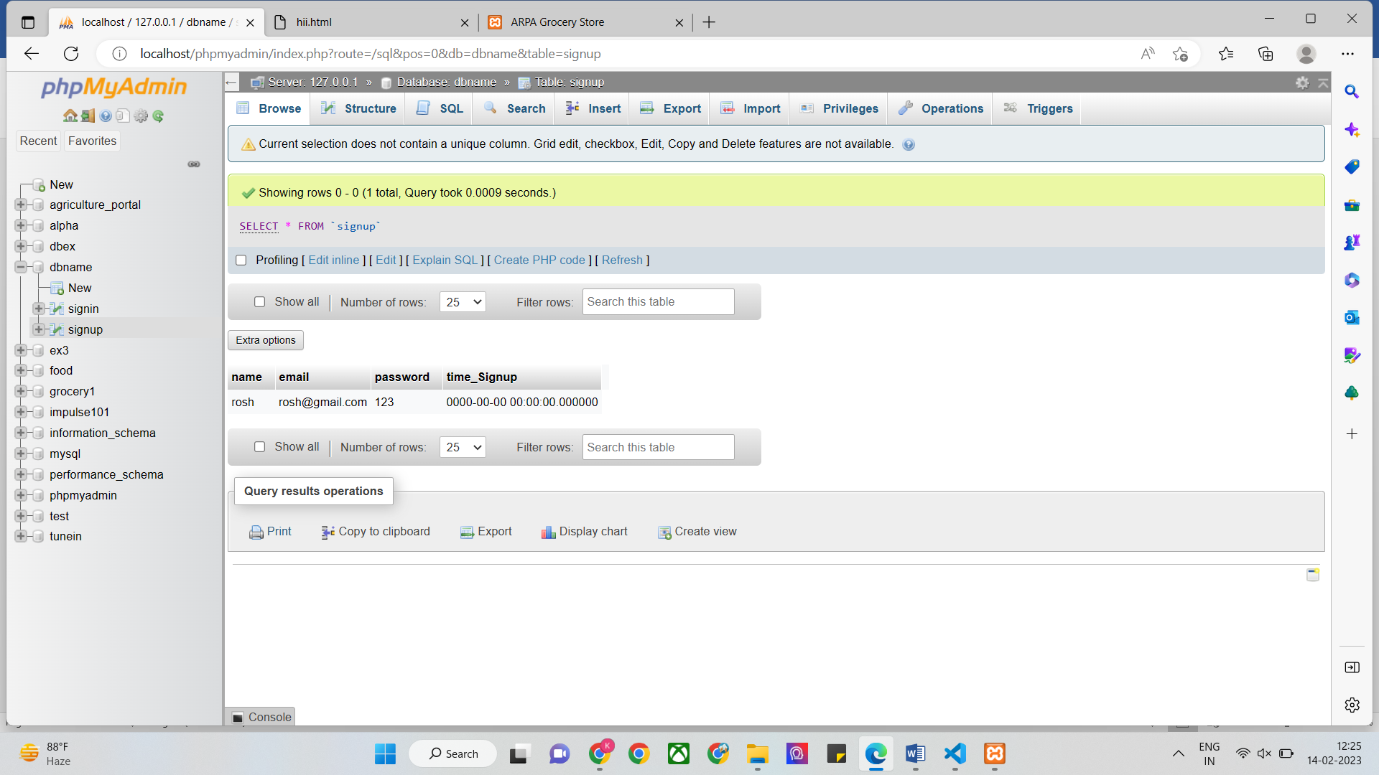

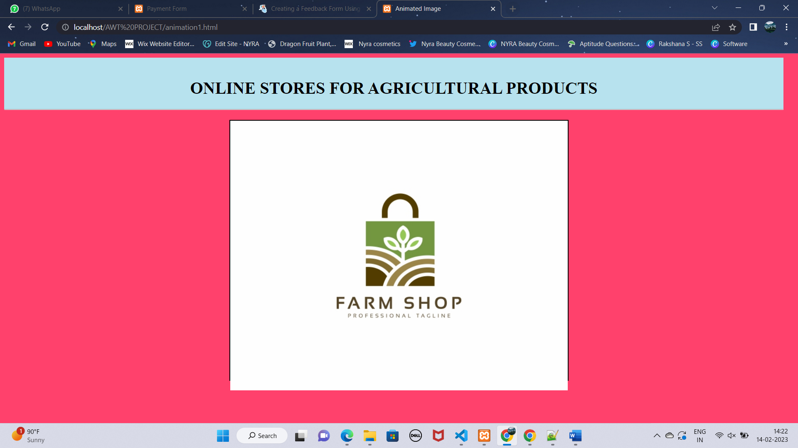

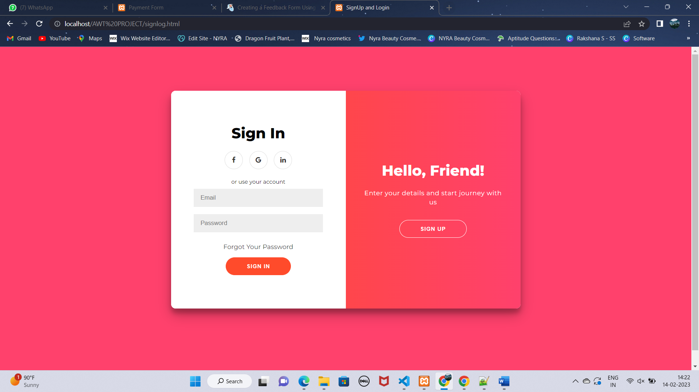

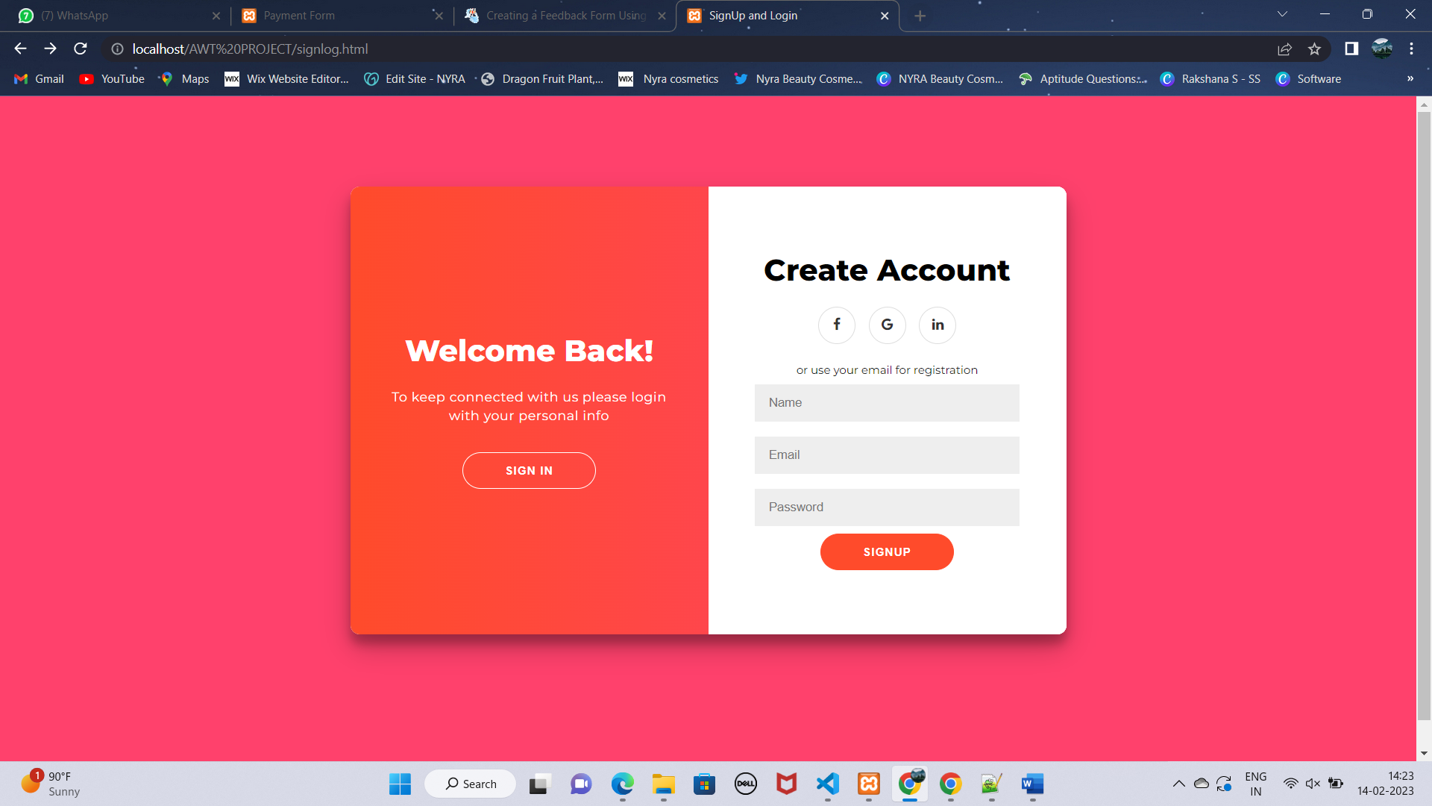

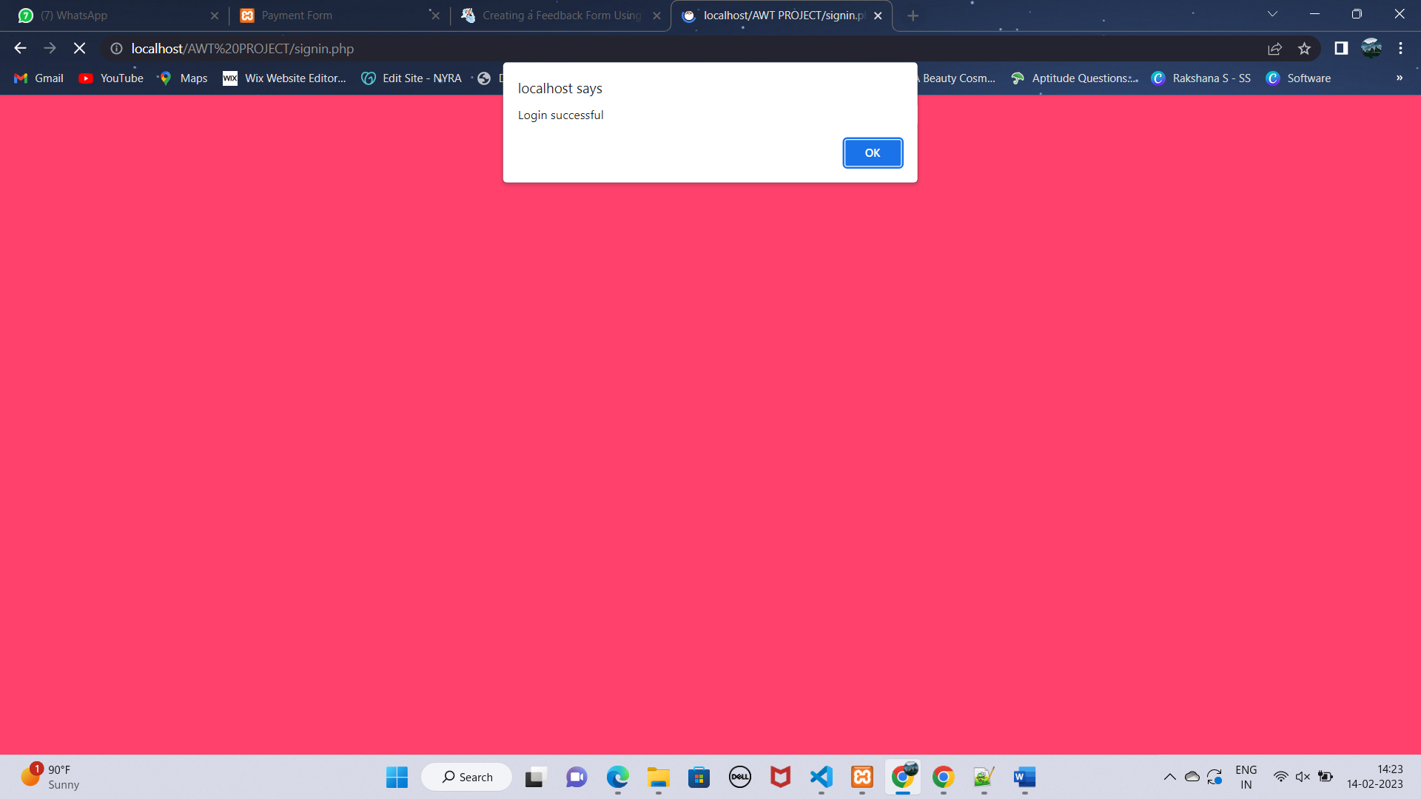

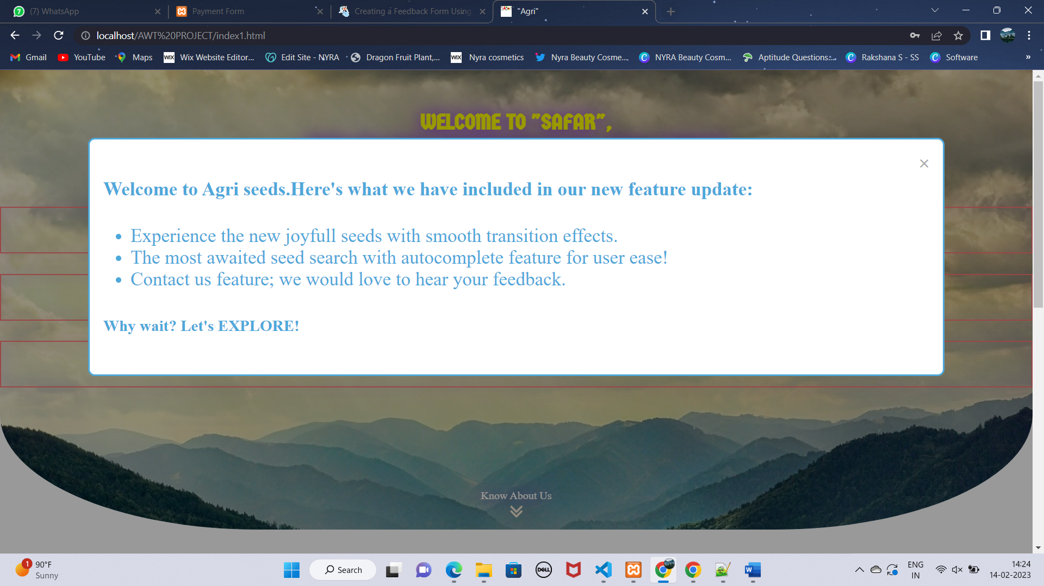

UI design:

